|  |  |
| --- | --- |
| Date and Time of Notification: | Tuesday 8th June 2021 9.15am |
| Person / Company: | Coomalie Community Government Council |
| Incident: | Fire in landfill area and green waste, Adelaide River Waste Management Facility |
| (a) the incident causing or threatening to cause pollution | A wildfire on Dorat Road, Adelaide River has jumped a firebreak and entered the Adelaide River Waste Management Facility. |
| (b) the place where the incident occurred | Adelaide River Waste Management Facility, Dorat Road, Adelaide River |
| (c) the date and time of the incident | Approximately 02.30pm  Sunday 6th June 2021 |
| (d) how the pollution has occurred, is occurring or may occur | A wildfire on Dorat Road, Adelaide River (refer extract from NT PFES Fire Incident Map) has broken containment lines and crossed a firebreak and entered the Adelaide River Waste Management Facility.  **NB UPDATE 8TH JUNE 2021**  The fire in the green waste is completely extinguished. However, reviewing the location of the green waste, its distance from the other fire, firebreaks, etc, members from the Adelaide River FERG are of the opinion that the fire is most likely deliberately lit. Council has reported the matter to Northern Territory Police and requested a Promis No.  Images are attached. These were taken Monday 7th June 2021. |
| (e) the attempts made to prevent, reduce, control, rectify or clean up the pollution or resultant environmental harm caused or threatening to be caused by the incident | Adelaide River FERG who were attending the wildfire contacted the Works and Services Supervisor on Sunday 6th June 2021 at approx. 2.00pm to advise that a fire was travelling from the west toward the landfill. Council enlisted the services of a contractor to complement the efforts of the FERG. Plant included water truck and deployment of an excavator.  At the time of preparing this report the fire is extinguished and Council Officers will continue to monitor the site. |
| (f) the identity of the person notifying the NT EPA | Chief Executive Officer |

Screen Shot of NT Fire Incident Map

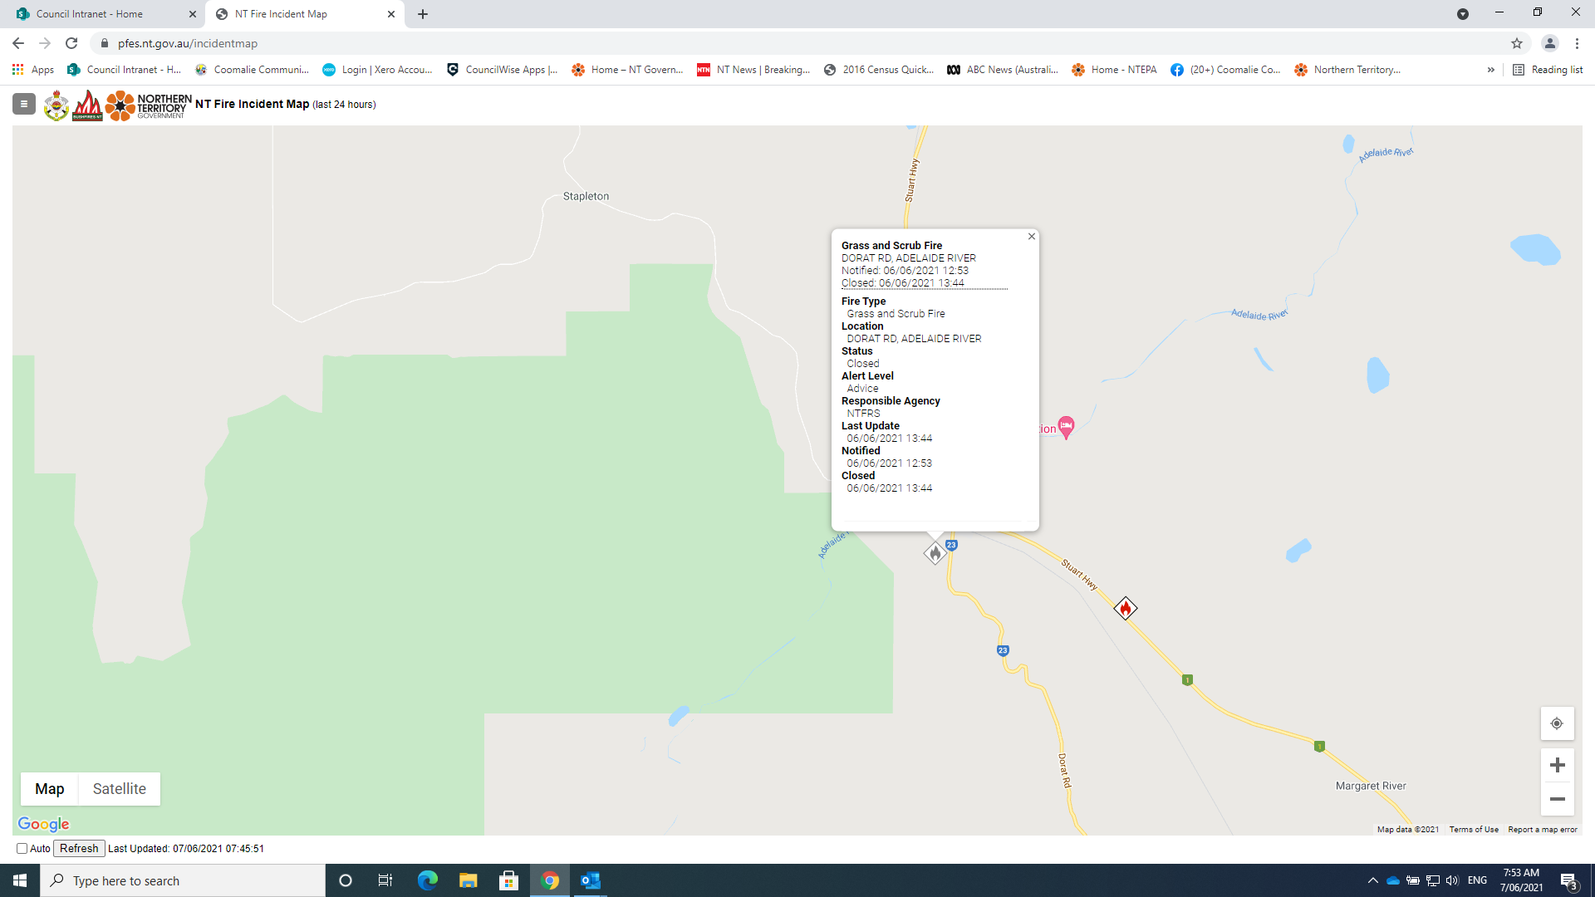

Images of Adelaide River Waste Management Facility, Monday 7th June 2021.

